Rachel Law

8610717122

Winter ‘16

CS 177 - Modeling and Simulation

**Lab 1**

**Exercise 1**

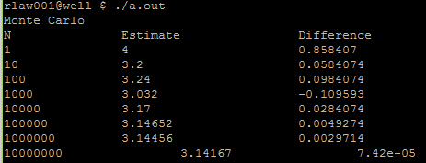

**Exercise 2**

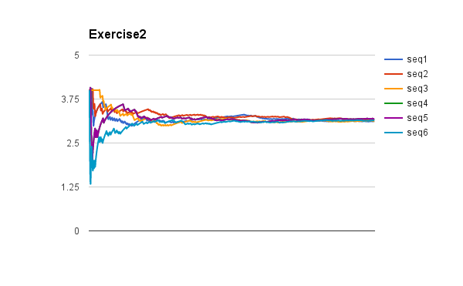

**Exercise 3**

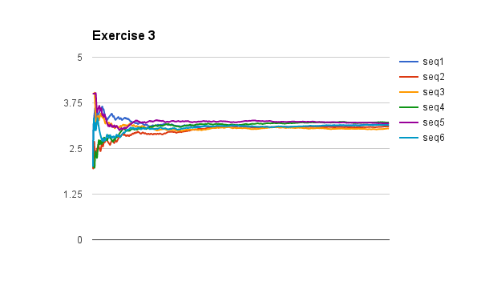

**Question:**

Why do you think this method is better than the one introduced in Exercise 1? (Hint: think of what kind of values you get when you get exactly 1 datapoint)

This method is better than exercise 1 because we have essentially 6 (consistently n taken) datapoint sets versus 8 (randomly n) taken datapoints. Having 8 datasets of different n provides no consistency and does not provide an ‘agreement’/’merging’ point to guess the value of PI. With 6 datapoint sets merging together, we can see at what N there becomes a strong agreement of what the answer to PI should be. Exercise 1 only provides different N, so of those results, we are not sure which is more ‘correct’.